**EMPLOYEE TABLE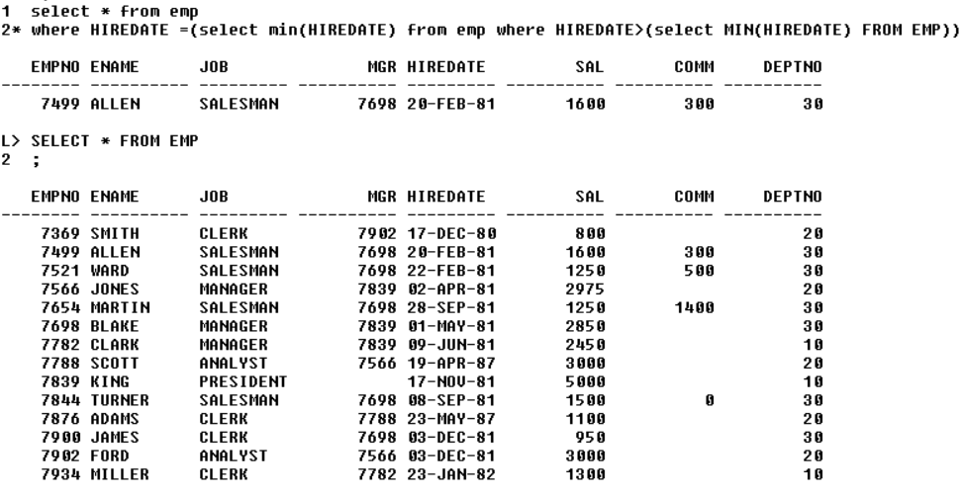­**

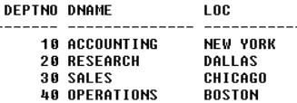

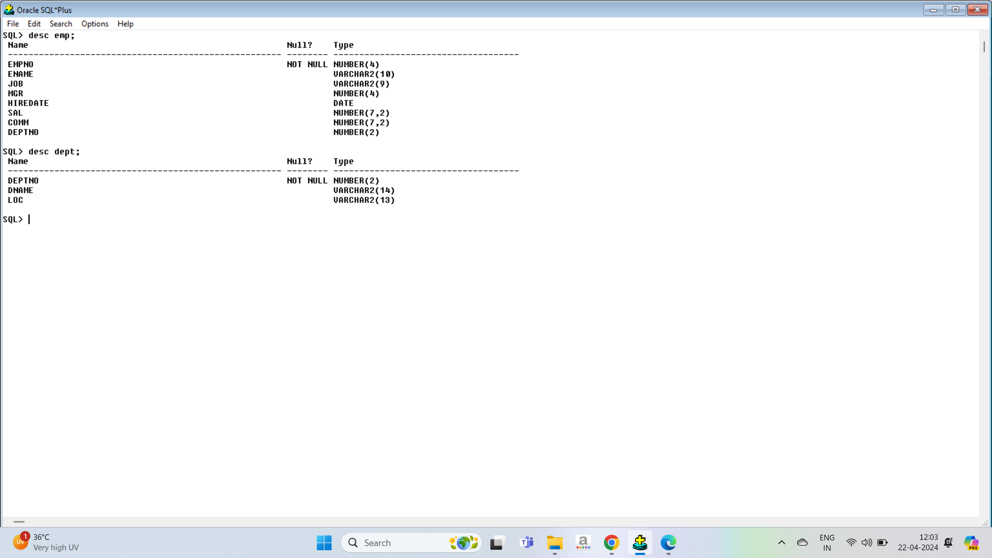

1. WAQTD Details of Employee Who are working I job as “Clerk”?
2. WAQTD Emp name, job and Joining Date of Employee Who are Getting Sal more than 1,100?
3. WAQTD Name of employee who joined after the year 81?
4. WAQTD Emp no, name, With Annual Salary?
5. WAQTD Name of employee who joined before the year 81?
6. WAQTD Details of Employee working in deptno “10” and “job clerk”?
7. WAQTD names of employee who are getting salary more than 1,300 and less than 5000?
8. WAQTD Details od employee who are joined after 82 and before the year 87?
9. WAQTD names of employee who are getting comm more than 500 and working as the job “clerk” (or) “salesman”?
10. WAQTD details of employee who are working in deptno “10” (or)”30” and working as “clerk” ang getting salary more than 1,500?
11. WAQTD name and deptno along with job for the employee working in deptno “10”?
12. WAQTD name and deptno along with job who working as “manager” in deptno 10?
13. WAQTD names, deptno, salary, of the employee who working in deptno “20” and earning less than “3000”?
14. WAQTD names and salary of the employee if employee earns more than 1250 but less than 3000?
15. WAQTD name and deptno of the employee who are working in deptno 10 and 20?
16. WAQTD name and salary and deptno of the employee who employee get more then 1250 but less than 4000 and working in deptno 20
17. WAQTD name, job of the employee working as “manager” in deptno “30”?
18. WAQTD name, deptno, job of the employee working as a manager in dept 10 or 30?
19. WAQTD name, job, deptno , salary of employees working as “clerk” (or)”salesman” in deptno “10”(or) “30” and earning more than 1800?
20. WAQTD details of employee working as “clerk” and earning less than 1500?
21. WAQTD names and “Hire date” of employee working as “manager” in deptno “30”?
22. WAQTD details of employee Whose name is starting with “J”?
23. WAQTD names of employee Which name contains Character “A” ?
24. WAQTD names of employee Whose id is ends with “8”?
25. WAQTD details of employees who joined in the year “81”?
26. WAQTD details of employees who joined in the month “December”?
27. WAQTD details od employee whose name contain two characters as “A”?
28. WAQTD names of employees whose name contain word like “lake”?
29. WAQTD details of employees whose names contains “lle”?
30. WAQTD name, deptno of employees working in dept “10” and hired date is 2019?
31. WAQTD name, sal, and hired date of employee deptno “20” and sal greter than 2000?
32. WAQTD names and deptno of the employees whos salary is between 100 to 3000?
33. WAQTD details of employee working in dept “10” and hired during 2019?
34. WAQTD details of employees hired date in 1981 and deptno “20”?
35. WAQTD names of employee who is not getting sal?
36. WAQTD names of employees Whose name is “Smith”?
37. WAQTD names of employees whose Don’t Have “report manager”?
38. WAQTD details of employees that “salesman” in “deptno” 30?
39. WAQTD list of employees in dept “30” and having salary greater than 1500?
40. WAQTD details of employees whose name starts with “s” and “A”?
41. WAQTD details of employees Whose name starts with “A” and ends with “y”?
42. WAQTD names of employees Whose names are starting With “S”?
43. WAQTD names of employees who are having Reporting Manager in deptno “10”?
44. WAQTD details of employees whose comm is null and job as”clerk”?
45. WAQTD names of employees whose job is “salesman” and deptno”30”?
46. List all the analysist in deptno “30” with sal more than “2450”?
47. WAQTD details of employees whose names starts with “M” and “J”?
48. List of employees whose name dose not end with “ES” (or) “R”?
49. WAQTD details of employees whose name dose not end with “A” (or) “SH”?
50. List of employees who are salesman having “E” as last character?
51. WAQTD details of employees who having reporting manager in deptno “10” Along with 10% hike in sal?
52. WAQTD list of employees who are joined after year “81”?
53. WAQTD details of employees working as manager and clerk in deptno 10 and 20?
54. List all the employees who are joined in NOV?
55. WAQTD details of employees whose names start with “A” and ends “A”?
56. WAQTD names of employee if the employee name has char “A” 2tims?
57. WAQTD names of employees whose names are ends with “A”?
58. WAQTD names of employees Whose names are ends with “A” and working iin deptno 20 and joined after “81”?
59. WAQTD details of employees whose names contain “S” 2 times?
60. WAQTD total salary paid to the salesman?
61. WAQTD highest salary paid foe clerk?
62. WAQTD Average salary paid for manager (or) clerk (or) salesman?
63. WAQTD no of persons working as clerk?
64. WAQTD no of persons working as analyst and highest salary paid for analyst?
65. WAQTD total salary paid for each dept?
66. WAQTD no of persons who joined in year 81?
67. WAQTD details of employees who are getting more than 1500 in each deptno?
68. WAQTD no of persons, names starting with “S” (or) having “A” in each dept?
69. WAQTD no of employees reporting for each reporting manager?
70. WAQTD details of employees who are getting same salary?
71. WAQTD only depts which is having more than 4 employees?
72. WAQTD jobs which is having maximum sal moe than 2000?
73. WAQTD no of persond more than 2 in each year?
74. WAQTD no of employees whose getting more than 2000 and joining in the year 81 (or) 82 in each job?
75. WAQTD no of employees working in each job whose name is contain charactrt “A” (or) “T” in same name?
76. WAQTD get the max paid job?
77. WAQTD details of employee who joined after “james”?
78. WAQTD names of employees who are getting salary more than Clerk?
79. WAQTD names of employee who are working in same job as “alean” (or) workin in deptno as “king”?
80. WAQTD details of employees who are getting saley more than “word and less than “jones”?
81. WAQTD deptno of “Alen”?
82. WAQTD Branch of “rose”
83. WAQTD details of employee with their salary whose having sal grater than “alien” (or) “miller” (or) “smith”?
84. WAQTD Names , sal and deptno odf employees if there are working in deptno of smith (or) alyin (or) king and getting salary more than “word” (or) “clerk”
85. WAQTD details of employee whose joined in the same year as “alen” (or) “king